Avocado Flavoured Pudding Mix  Record ID: 5661151  Company: Forisa Nusapersada  Manufacturer: Forisa Nusapersada  Brand: Silky Pudding Mom's Recipe  Category: Desserts & Ice Cream  Sub-Category: Shelf-Stable Desserts  Market: Indonesia  Store Name: Carrefour  Store Type: Supermarket  Store Address: Jakarta 11610  Date Published: May 2018  Product source: Shopper  Launch Type: New Product  Price in local currency: IDR17300.00  Price in US Dollars: 1.25  Price in Euros: 1.03  Bar Code: 8992933441215 | 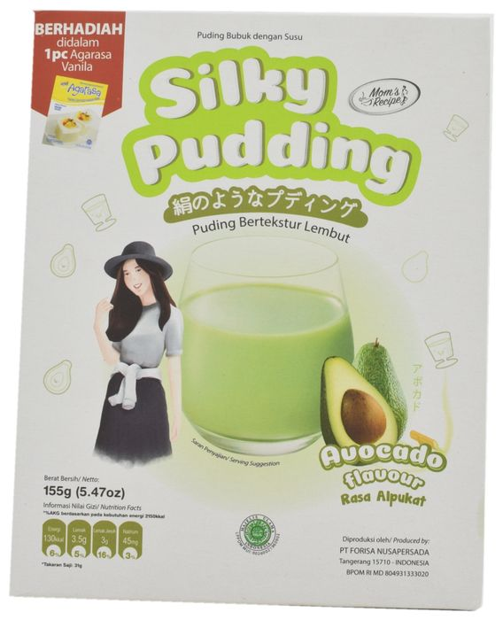
Product Description
Silky Pudding Mom's Recipe Pudding Bubuk dengan Susu Rasa Alpukat (Avocado Flavoured Pudding Mix) is made with skimmed milk and features a smooth texture. The halal certified product retails in a 155g pack which includes a free pack of Agarasa Vanilla.
Packaging Details
 | Primary | Secondary
Package Type | Flexible | Carton
Package Material | Multi laminate | Board plastic lined

Product Analysis
Pack Size: 155.000 g
Storage: Shelf stable
Formats & Textures (Beauty & Personal Care):
Textures (Food & Drink): Smooth (Silky / Velvety / Creamy / Buttery)
Alcohol By Volume (%):
Private Label: Branded
Store Type: Supermarket
Product Variants
Product Variant | Flavours | Format Type | Claims | Still Selling
Avocado Flavoured Pudding Mix | Avocado | — | Low/No/Reduced Fat,  Halal | —

Chocolate Flavour Soft Pudding Mix | Chocolate | — | Low/No/Reduced Fat,  Halal | —
Bubble Gum Flavoured Pudding Mix | Bubble Gum/Chewing Gum | — | Low/No/Reduced Fat,  Halal | —
Taro Flavoured Pudding Mix | Taro | — | Low/No/Reduced Fat,  Halal | —

Ingredients (Standard form): White Sugar, Skimmed Milk Powder (Powdered, Skimmed), Carrageenan, Non Dairy Creamer (Creamer, Non-Dairy), Avocado Extract (Extract), Avocado Flavor (Artificial), food colour (Tartrazine, Brilliant Blue FCF (Furocoumarin Free))
Ingredients (On Pack): sugar, skim milk powder, carrageenan, non dairy creamer, avocado extract (1.5%), synthetic avocado flavor, food colour (tartrazine Ci 19140, brilliant blue FCF CI 42090)
Nutrition: Per 31g serving (5 servings per pack): Energy 130kcal, Total fat 3.5g (5% RDA) (of which Saturated Fat 3g (16% RDA)), Protein 1g (2% RDA), Total carbohydrates 25g (8% RDA) (of which Sugars 17g), Sodium 45mg (3% RDA)
Branded Comparison:
Annotations

Additional Product Images
